

|  |  |  |
| --- | --- | --- |
| Mathematics Department | |  |
| Course: A2MAA | |
| Topic Title: Test 3 Calculator Free | |
| Student Name:_____________________________________ | Date: ____________ | | |
| Special Instructions: Formula Sheet allowed and no calculators | Time Allowed: 10 minutes | | |
| **Show all working clearly** | Marks: / 10 | | |

**Question 1. (4 marks)**

Use the triangle below to obtain the fractions for the trigonometric ratios given.

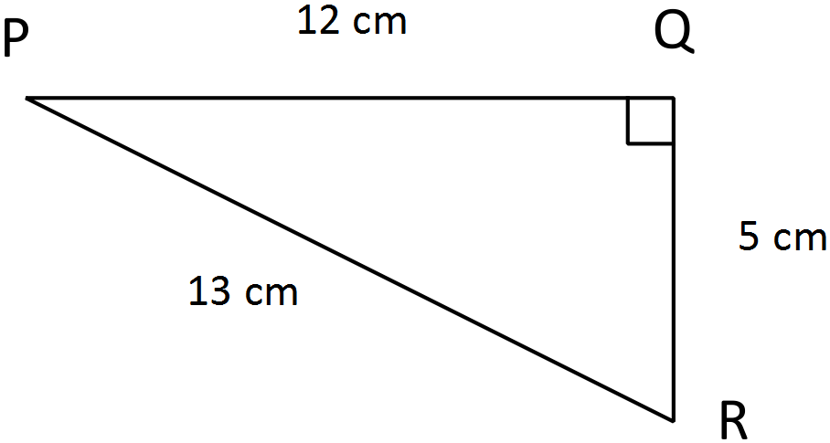

1. sin *P* = $\frac{5}{13}$
2. sin *R* = $\frac{12}{13}$
3. cos *R* = $\frac{5}{13}$
4. tan *P* = $\frac{5}{12}$

**Question 2. (2 marks)**

If $sin30=0.5$, calculate the length of the missing side.

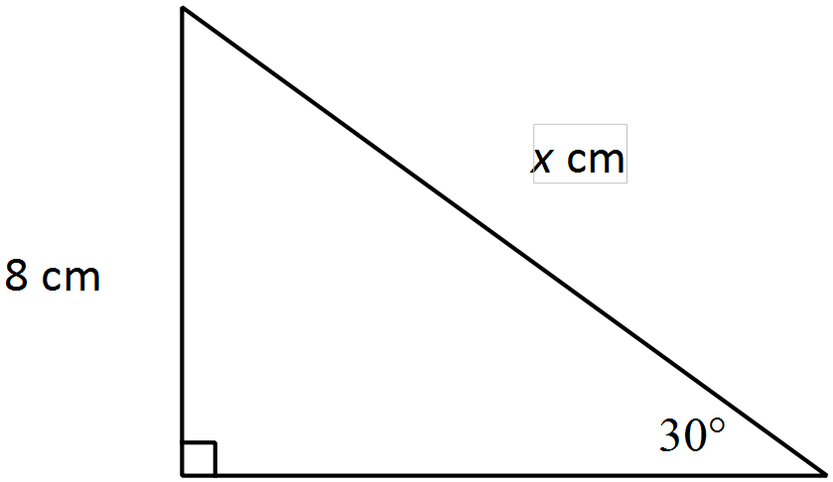 $sin30°=\frac{8}{x}$

$x=\frac{8}{0.5}$

$x=16cm$

**Question 3. (2 marks)**

Calculate the bearing of A from B in the following two scenarios.

1. b)

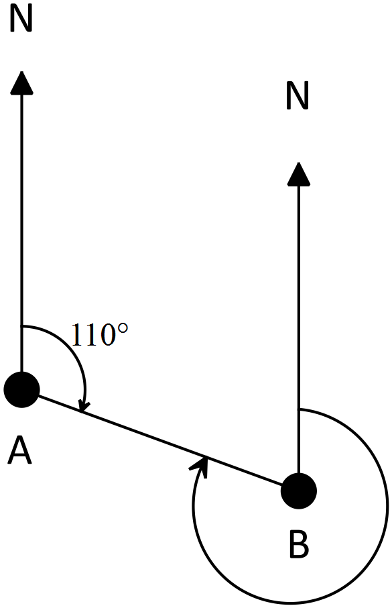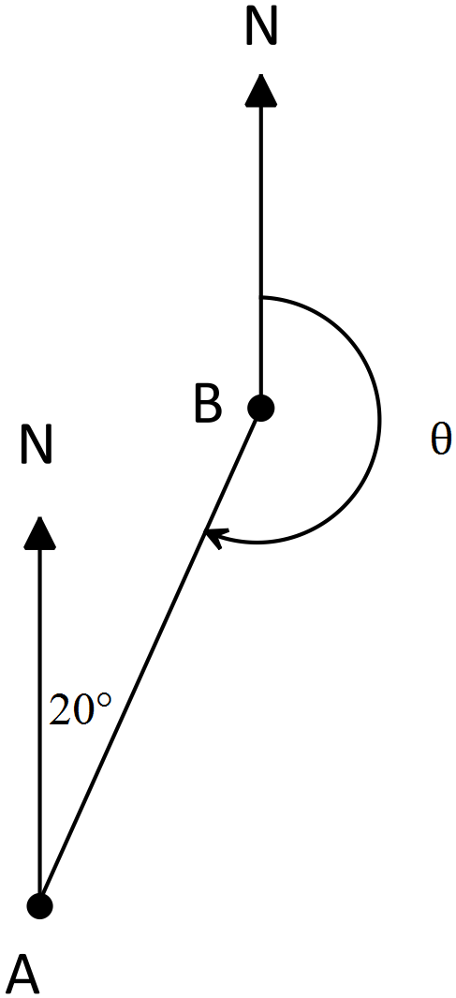

Bearing of A from B is 200° Bearing of A from B is 290°

**Question 4. (2 marks)**

If $sin30=0.5$, calculate the area of the triangle below.

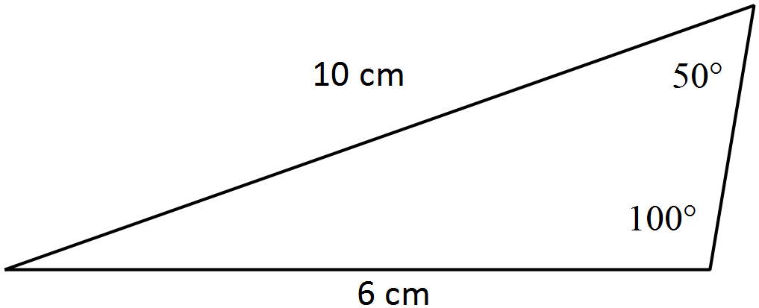

Area =

=

= 15cm2